**EXPERIMENT-7**

**IMPLEMENTATION OF HYBRID TOPOLOGY (BUS AND RING**

**TOPOLOGY) USING PACKET TRACER**

**Aim:** To Implement a hybrid topology using packet tracer and hence to transmit

data between the devices connected using tree topology.

**Software / Apparatus required:** Packet Tracer / End devices, Hubs, connectors.

**Steps for building topology:**

**Step 1: Start Packet Tracer**

**Step 2: Choosing Devices and Connections**

**Step 3: Building the Topology – Adding Hosts**

Single click on the **End Devices**.

Single click on the **Generic** host.

Move the cursor into topology area.

Single click in the topology area and it copies the device.

**Step 4: Building the Bus Topology – Connecting the Hosts to Hubs**

Select a Hub, by clicking once on **Hub** and once on a **generic Hub**

Add the Hub by moving the plus sign “**+**”

**Step 5: Building the Ring Topology – Connecting the Hosts to Hubs**

Select a Hub, by clicking once on **Hub** and once on a **generic Hub**

Add the Hub by moving the plus sign “**+**”

**Step 5: Connect PCs to Hub by first choosing Connections**

Click once on the **Automatic cable selector**

Click once on **PC2**

Choose **Fast Ethernet**

Drag the cursor to **Hub0**

Click once on **Hub0**

**Proceeding in this way create three Bus topologies**

**Step 6: Building the Tree Topology – Connecting the Hubs to Active Hub**

Connect the hubs of star topologies to active hub to create tree topology.

**Step 7: Configuring IP Addresses and Subnet Masks on the Hosts**

To start communication between the hosts IP Addresses and Subnet Masks had to

be configured on the devices. Click once on PC0. Choose the Config tab and click

on FastEthernet0. Type the IP address in its field. Click on the subnet mask. It will

be Generated automatically.

**Step 8: Verifying Connectivity in Realtime Mode**

Be sure you are in **Realtime** mode.

Select the **Add Simple PDU** tool used to ping devices.

Click once on PC0, then once on PC3.

The PDU **Last Status** should show as **Successful**.

**Step 9:** **Verifying Connectivity in Simulation Mode**

Be sure you are in **Simulation** mode.

Deselect all filters (All/None) and select only **ICMP**.

Select the **Add Simple PDU** tool used to ping devices

Click once on PC0, then once on PC3.

Continue clicking **Capture/Forward** button until the ICMP ping is completed. The ICMP

messages move between the hosts, hub and switch. The PDU **Last Status** should show as **Successful**.

**Diagram:**

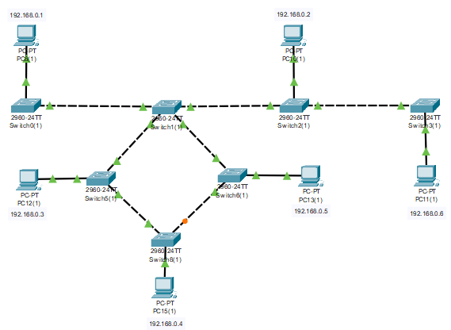

**Output:**

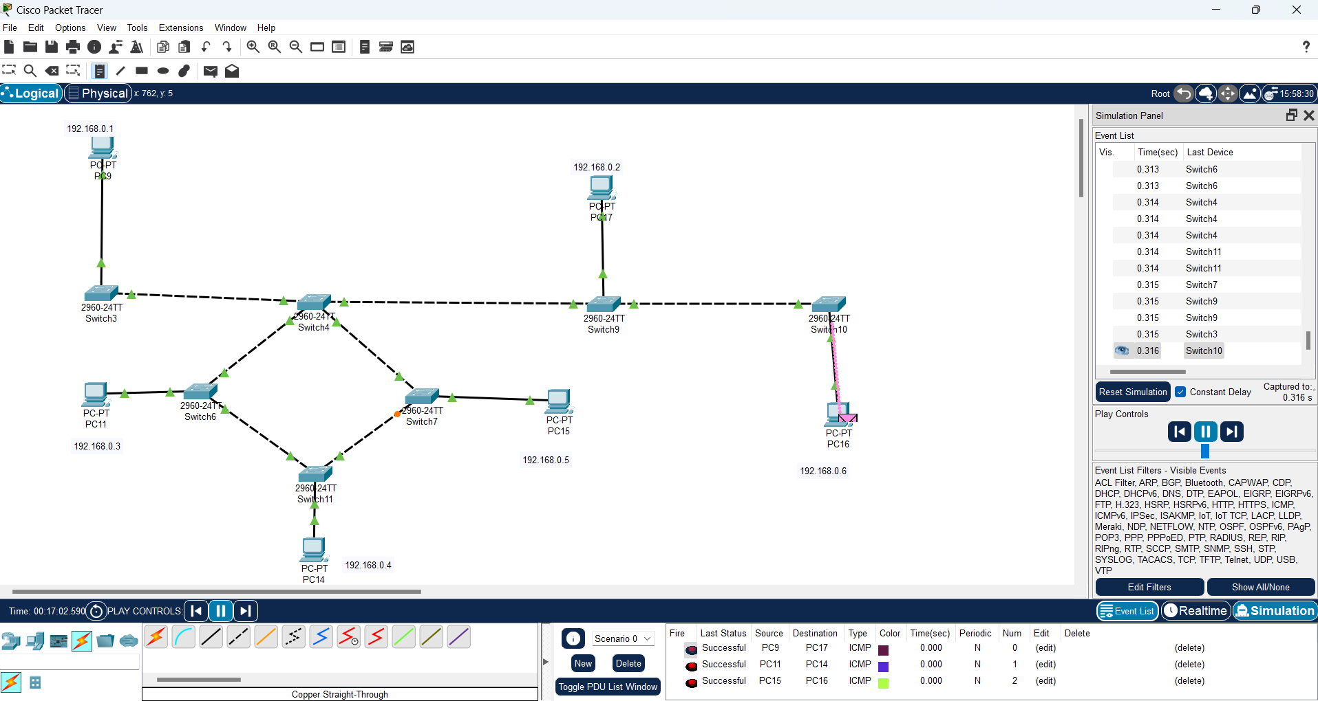

**Result:** Thus the Hybrid topology is implemented with Packet Tracer simulation Tool.